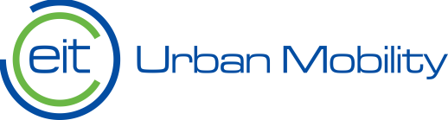

Co-create NEB 2027 Call

Guidelines for applicants

EIT Urban Mobility - Mobility for more liveable urban spaces

Business Plan 2026–2028

EIT Urban Mobility
Barcelona| 15 July 2026

eiturbanmobility.eu

History of changes
Version | Publication Date | Change
1.0 | 22/04/2026 | Initial version

Contents
1. Submission process overview: PIC and PIF 1
2. Create an application 1
2.1. Main Information 2
2.2. Partner Information 5
2.3. Project Scope 7
2.4 Work Plan 10
2.5. Supporting documents 14
2.6. Budget 15
3. Submit your proposal 16

1. Submission process overview: PIC and PIF

Before starting to draft a proposal, all applicants must follow the following steps:
Step 1: Obtain a Participant Identification Code (PIC)
All applicants submitting to this Call must register themselves in the EU Funding & Tenders Opportunities Portal to obtain a valid nine digit PIC number.
If the applicant already has a PIC, no new registration is required.
If you do not know if you already has a PIC number, you can verify directly on the EU Portal (click here).

Step 2: Register or access the EIT Urban Mobility Programmes Portal (NetSuite)
  - If you are already registered in the EIT Urban Mobility Programmes Portal (NetSuite), please log in by going to step 3.
  - If you have never registered in the system, please go to the Programmes Portal and click on “Register”. Then select Option 1: “I am an organisation/individual or an existing EITUM Academy student applying for EITM Calls” and complete the Partner Information Form (PIF) with the required details.

If the system denies your registration because the PIC number corresponds to an already registered entity, or because your email address is associated with an existing entity, please contact servicedesk@eiturbanmobility.eu.
Step 3: Submit the application in NetSuite
Once registered and logged in, applicants must:
- Access the EIT Urban Mobility NetSuite platform.
- Navigate to: >Grant Management>Grant Management> Open Calls.
- Select the call Co-create NEB 2027
- Complete all mandatory fields of the online application form.
- Submit the complete proposal before the relevant deadline indicated in the Call Manual.
Applications submitted after the deadline will not be considered.

2. Create an application

Go to EIT Urban Mobility Programmes Portal (NetSuite), click on > Grant Management > Open Calls
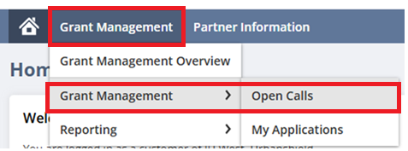
Choose the Co-create NEB 2027. Once you click on “apply”, a new Application Form is created, and you will be able to start filling it in with all the information of your project.
The Application Form is divided in six sections, which are detailed below.

2.1. Main Information

The ID proposal number is generated automatically by the system when you first save your proposal.
When entering the project title and acronym, remember this will be the official name publicly used to promote your project. Choose the name wisely.
Please select the primary and secondary thematic areas that your project most closely aligns with. Three proposals will be selected for each thematic area (see Section 6.2.2 of the Call Manual).

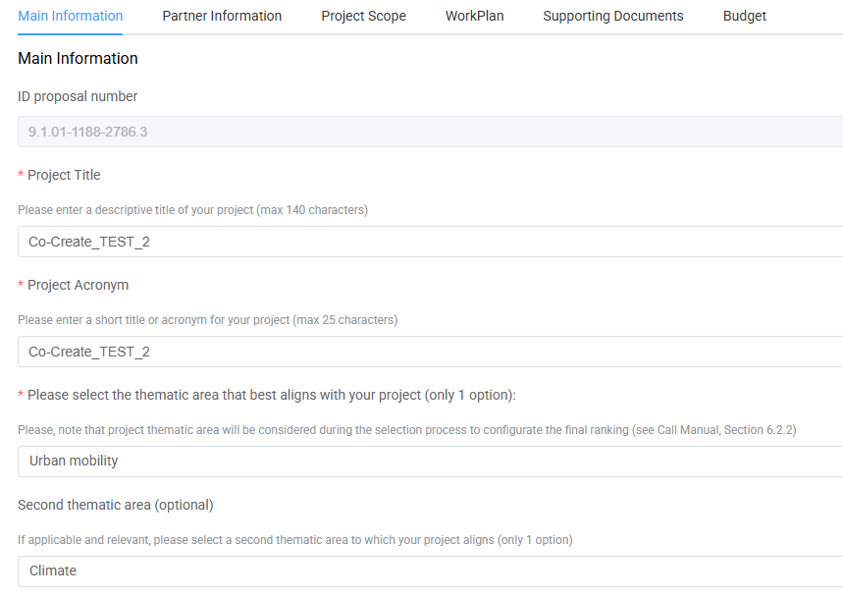
As indicated in the Call Manual, the tentative start date of the project is 1 February 2027, with the maximum duration of 10 months (tentative end date is 30 November 2027).
The sections “total budget”, “total EIT funding” and “total co-funding” will be populated automatically by the system once you insert the budget. Please indicate the country and the city/region where the project will be implemented.

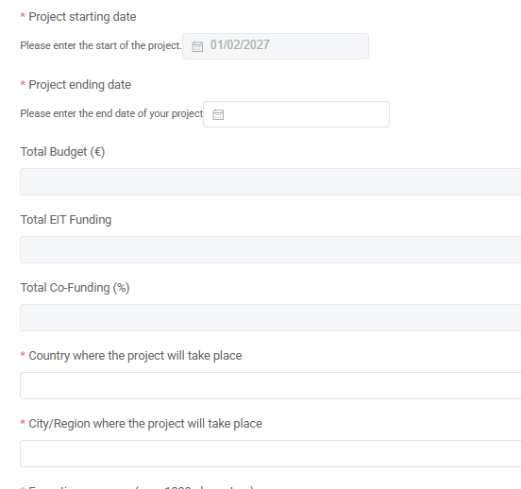
When writing the executive summary, remember this must provide a comprehensive but general overview of the project and that, if your project is selected for funding, it will be used for dissemination purposes. We suggest you fill in this section once you have completed all other sections and therefore have a clear overview of your project.

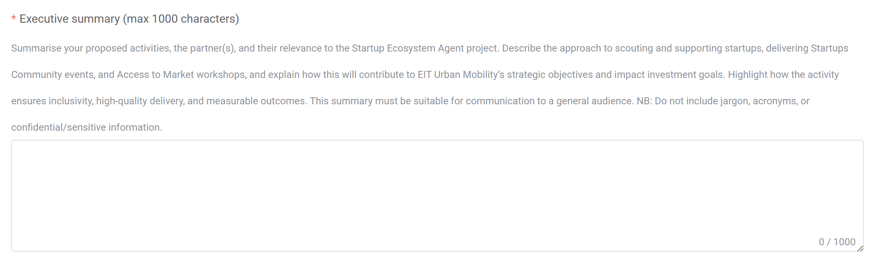
You must enter a minimum of three and a maximum of five keywords (to be selected from a drop-down menu) and a minimum of three and a maximum of five self-defined keywords (which you can therefore freely type). Make sure you select the keywords that best represent your project.

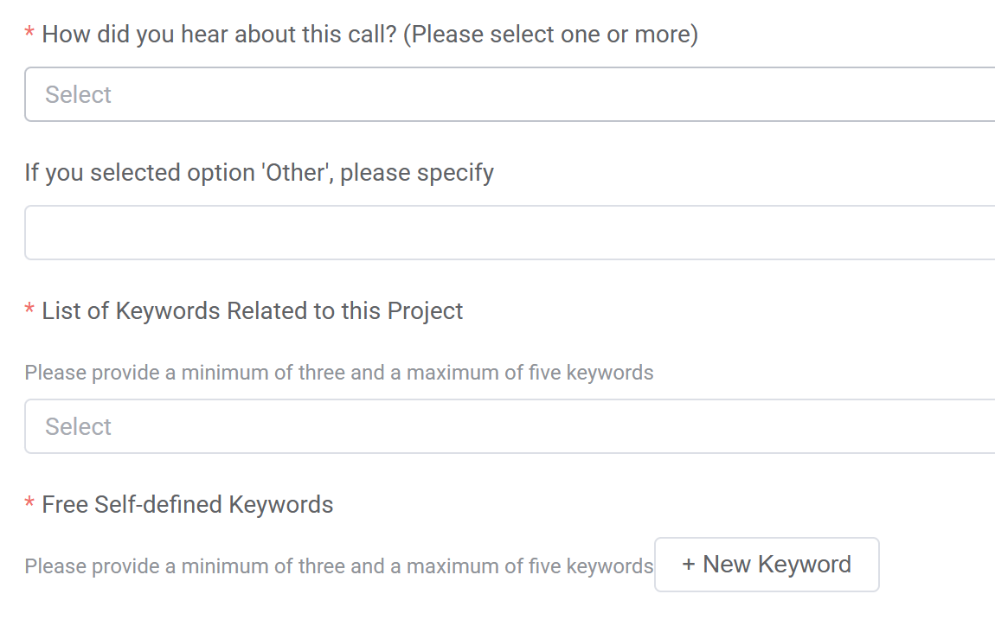
Before moving to the next tab, remember to click on the “save” button.

2.2. Partner Information
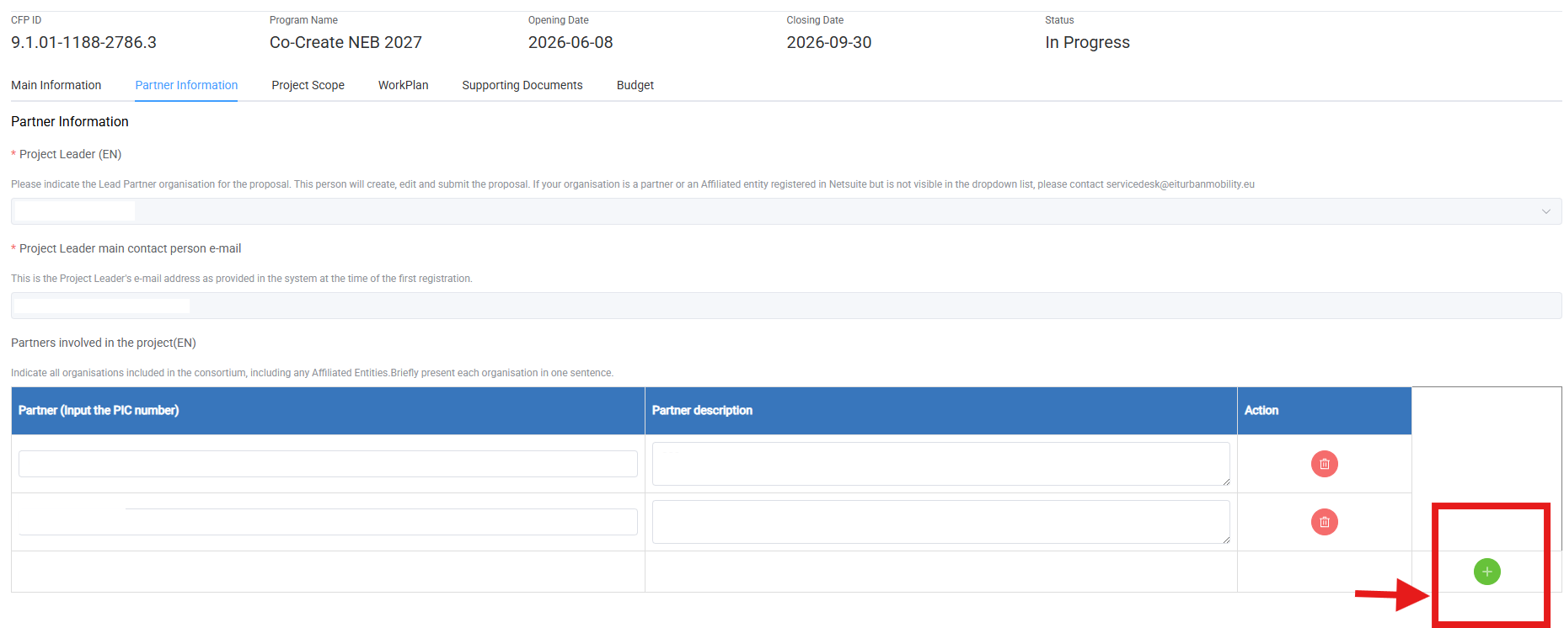
The “project leader” is automatically assigned by the system, and it is the contact of the organisation that creates the Application Form.
The e-mail of the main contact person is also automatically populated and is always the e-mail address of the contact that created the Application Form.
In the section “partners involved in the project” you must list all partners that will be involved in the project. Please note that Co-create NEB proposals must be composed of a consortium with a minimum of 2 and a maximum of 4 legal entities. Please provide a one-sentence description of each organisation. More detailed information on each organisation's role in the project will be requested later in the application.
The project leader is automatically included by the system in the list. All other partners must be added by clicking on the “plus” button.
Once you click on the “plus” button, you must enter the full PIC of that specific partner. Once you enter the full PIC, you will be able to select the organisation from the drop-down menu and include it as a partner.
If the organisation you are looking for is not found in the list, please invite them to register in the EIT Urban Mobility Programmes Portal (NetSuite). Click on “Register” and then select Option 1: “I am an organisation/individual or an existing EITUM Academy student applying for EITM Calls” and complete the Partner Information Form (PIF) with the required details.

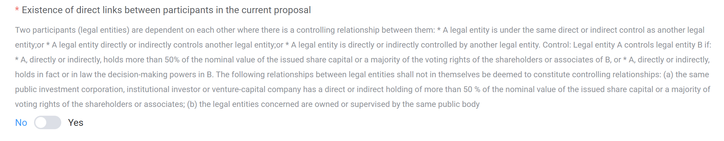
Once you have added all partners, you must indicate if there is any direct link between any of them. If there is a direct link, you must indicate which partners are linked and which type of link they have.

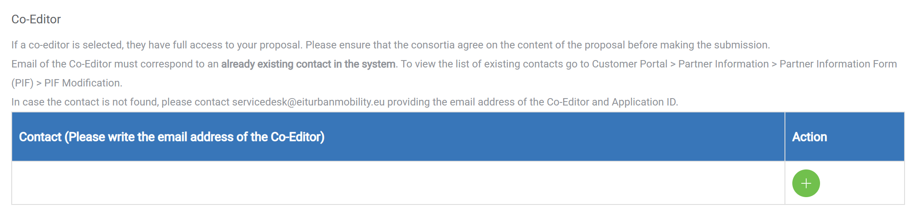
Under this section you can also add any contact to whom you wish to grant co-editor rights. To add a contact, you must introduce the full and correct e-mail address. At that point, you will be able to select the contact from the drop-down menu.
If you cannot find your contact in the drop-down menu, you must ask the contact to register in NetSuite or to be added as contact person of an organisation already registered in the system.
We suggest granting co-editor rights only to a limited number of people and only when their direct contribution in filling in the Application Form is needed.
If you have one or more co-editors assigned to your proposal, make sure no more than one user is working on the Application Form at the time. If more users are working simultaneously in the Application Form, the system will not be able to save the work of all users, and this will cause a loss of information.
Please note that only the creator of the Application Form (that is, the main contact person for the proposal) can do the final submission of the proposal.
If you click on the “+” button to add a contact but then cannot find the user, remember to click on the delete button otherwise the system will give you an error message when clicking on “save”.
Before moving to the next tab, remember to click on the “save” button.

2.3. Project Scope

For this whole section: we recommend you prepare the answers offline and copy-paste them in the Application Form only once they are finalised. When filling in the final information in the system, we recommend you to save often (do not wait to have the whole tab completed before saving). Please note that some responses are subject to character limits. Ensure that your answers are concise and contain all the necessary information within the specified limit.
Remember that you are not allowed to include any URLs in your Application Form.
Under the Project Scope tab, you will need to answer the following questions:

Excellence, novelty, and innovation
- Need and relevance: Project background and social context (max 1800 characters)
Explain the local challenge that has led to your proposal. Please mention who the community affected by this challenge is, and whether you or any of the partners are part of it and/or have been working with it before. (You do not yet need to describe your proposal, as this will be addressed in a later question; please focus on the challenge you have identified).
- Alignment with the New European Bauhaus
How does your project relate to the values and working principles of the New European Bauhaus? No prior knowledge of NEB is required, and this alignment will be further developed during the programme. For reference, you can consult the NEB Compass here: Use the Compass - New European Bauhaus - European Union

  - Please briefly reflect on how your project aims to be sustainable (circularity, long-term thinking, environmental impact) (max 800 characters)

  - Please briefly reflect on how your project supports meaningful inclusion and participation. Please demonstrate how gender equity is considered, as well as the representation, participation, and access of underserved groups. (max 800 characters)

  - Please briefly reflect on how your project considers quality of place and experience (design, culture, identity) (max 800 characters)

Impact

- Proposed outcomes and outputs (max 1.500 characters)
List and briefly describe up to three main improvements/outcomes your project aims to achieve to enhance the community’s quality of life in the medium to long term through its neighbourhood spaces. For each of them, please list the outputs that will be produced or achieved to contribute to their realization. Please indicate the expected value of each mentioned output. (max three outputs per outcome).
* An outcome is defined as a specific change in behaviour, knowledge, skills, attitudes, or circumstances of beneficiaries resulting from project activities.
* An output refers to direct, tangible, and measurable products, goods, or services delivered (e.g. workshops, technical plans, participants trained, handbook produced, or other relevant achievements).
- Potential future durability and transferability of the solution (max. 1.000 characters)
Please describe how you envision the continuity of the project in this context or its transferability to other locations beyond this programme. Indicate any alignment with existing local strategies or policies, and how this may be relevant in the medium and long term.
- Target key group
Please select up to 3 options.
- For each selected target group, briefly explain why they are relevant to the challenge/project and how you expect to outreach, recruit and engage them to join the project. You will have the opportunity to describe your engagement, co-design and participatory methods later in the application. (max 1300 characters)

Quality and efficiency of the implementation
- Team capacity
Describe how each partner will contribute to the project. Make sure to indicate their relationship with the community and with any of the other partners.
  - Lead partner: Specify your key capacities and expertise and briefly explain your role in the project and consortium dynamics. (max 600 characters)

  - Partner 2: Specify their key capacities and expertise, and their expected role in the project and consortium dynamics. (max 600 characters)

  - Partner 3 (if applicable): Specify their key capacities and expertise, and their expected role in the project and consortium dynamics. (max 600 characters)

  - Partner 4 (if applicable): Specify their key capacities and expertise, and their expected role in the project and consortium dynamics. (max 600 characters)

- Budget (max 1.300 characters)
Demonstrate a clear and realistic allocation of the project budget (€58.000), showing alignment between the budget and the proposed activities, and a realistic prioritisation of resources.
- Co-creation methodologies (max 1.500 characters)
Describe how communities and target groups will be actively involved and engaged in shaping the project through meaningful participatory approaches, such as co-design processes, workshops, assemblies, or living labs.

Risk Management Plan
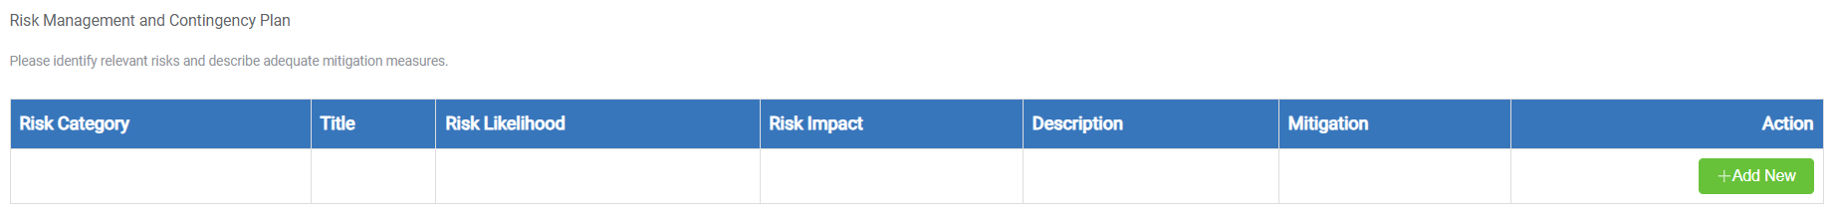Under the risk management section, we ask you to outline the risks potentially related to your project. This is an exercise for predicting some of the risks you might face during the implementation of the project and considering ways to mitigate them.
To add a risk, click on the “add new” button. You will be asked to choose the risk category, as well as the risk likelihood, from a drop-down menu.

Ethics and Security
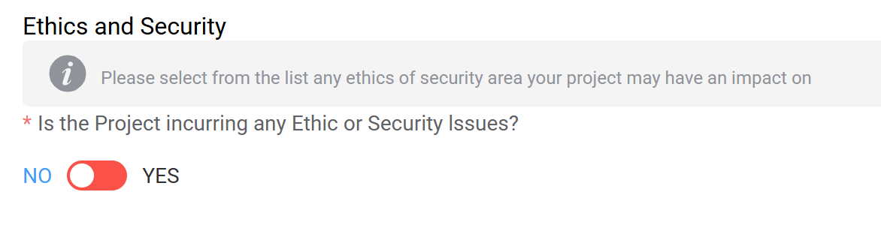
At the end of the Project Scope tab, you will find the ethics and security section.
If there are any ethics and security issues related to your project, please indicate which they are by selecting them from the drop-down menu (multiple selection is possible) and provide a description for each of the categories you have selected:
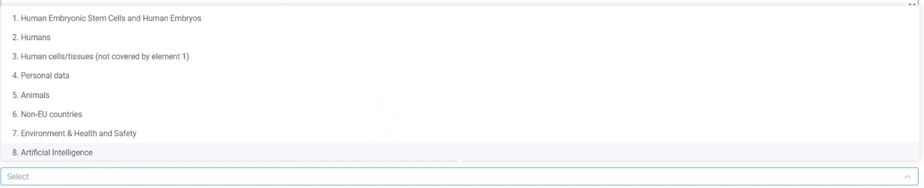
Before moving to the next tab, remember to click on the “save” button.

2.4 Work Plan

Work Packages
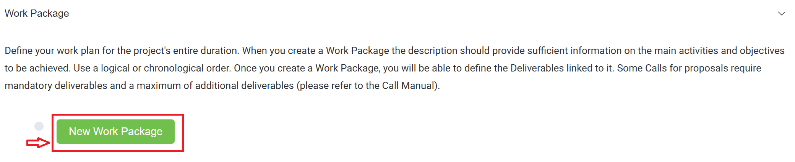
Click on “new work package” and create only one single Work Package titled “Project Implementation” and add the Applicant organisation as WP leader and all consortium members as WP contributors.
- Start date: February 1, 2027.
- End date: end of the project
[click on SAVE button]
In the Work Package Description define your work plan for the project's entire duration, organising your plan as a timeline (monthly, quarterly, or other meaningful structure). For each period, present and describe the main activities. Specify the key results expected in each activity.
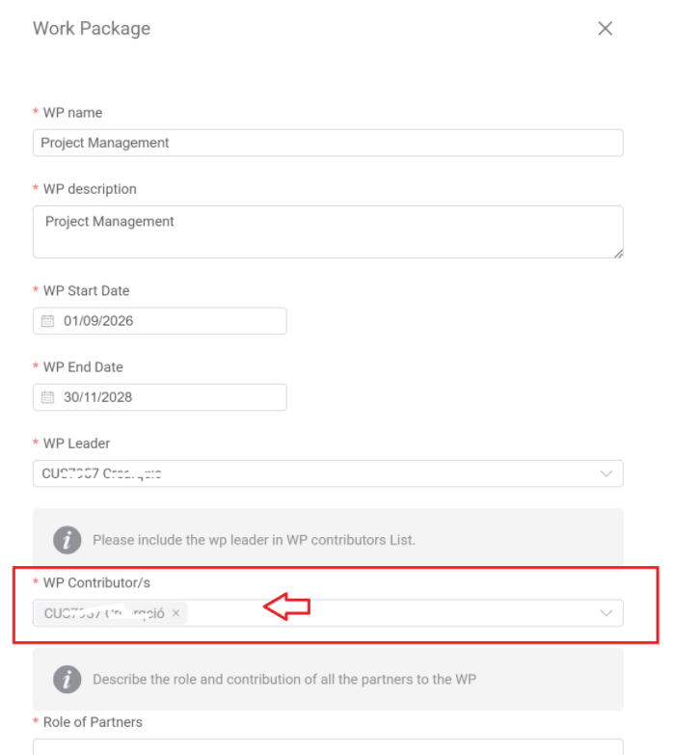

Deliverables
Deliverables document the implementation of the activities, the achievement of key outputs and the overall impact of the project. The deliverables specified need to fully demonstrate the project’s achievements and the judicious use of public funds.
Once you save a WP, it will be possible to link deliverables to it. To do so, simply click on “add deliverable” and a pop-up window will open.
As indicated in the Call Manual (See Section 3.4.4.2. Deliverables – Co-create NEB), all proposals must submit the following mandatory deliverables:
- Deliverable 1: Final report - Report presenting the activities implemented, results achieved, overall impact, and final project outcomes (end of the project)
The proposals must also submit one of the following deliverables, in accordance with the respective result they are expected to achieve.
- Deliverable 2_A: Public Space Improvement - Document describing public realm improvements, including pictures of the site before and after the intervention, and highlight key aspects that show how the space is integrated into its context and how it is being used by the community. Any relevant elements related to sustainability, materials, design, or other features, should be included (end of the project).

Or

- Deliverable 2_B: Research and/or new methodologies supporting improvements in the built environment - Report or graphic material providing actionable insights to improve the built environment within one or more neighbourhoods or regions, supporting public strategies and contribute to medium- and long-term impacts on the public sphere, including enhanced planning, policy-making, and/or community engagement (end of the project).
NOTE: Deliverables can only be added once the Work Package is created and must be added directly to the assigned Work Package.
Before moving to the next tab, remember to click on the “save” button.

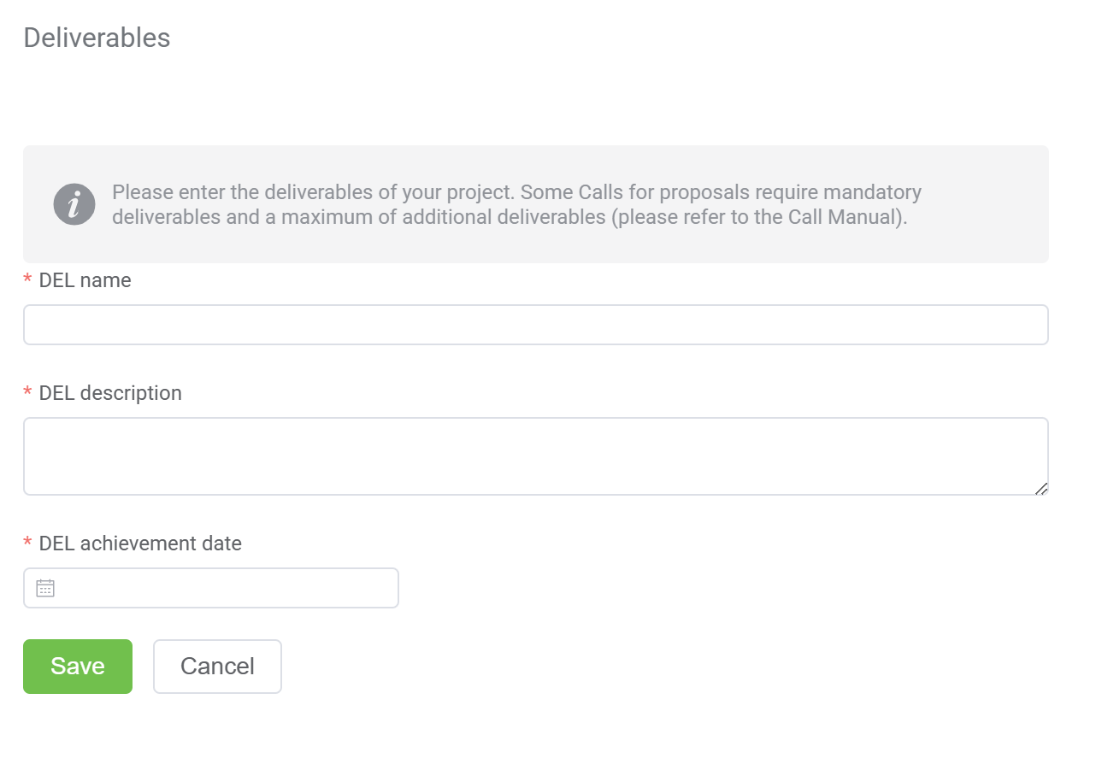

Key Performance Indicators (KPIs)
In the Application Form, you will need to select the corresponding KPI. Keep in mind that the achievement date cannot be after the end of the project.

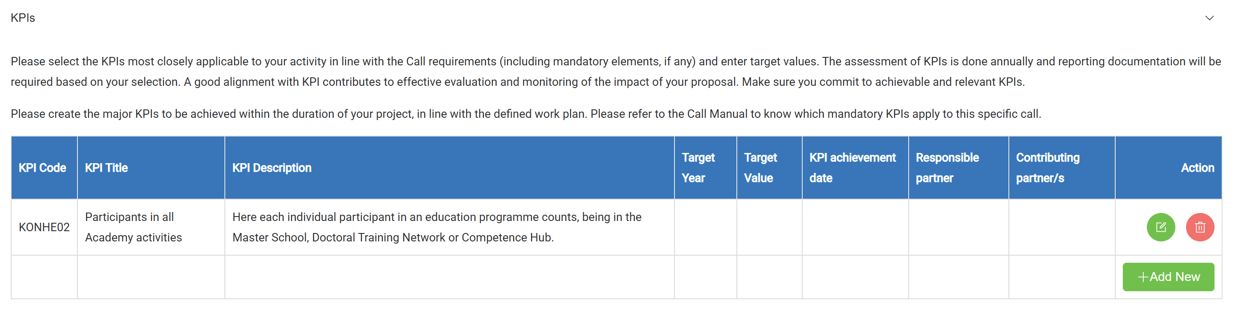
According to the Call Manual, all proposals must include the KPI EITHE08.1, with a minimum target of 25 participants in non-labelled education and training.
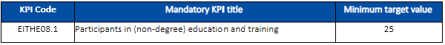
Proposals selecting the delivery of deliverable DEL 2_A must indicate the result in terms of the KPI KSN03, with a minimum target of 1 public space improvement.
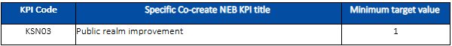
Before moving to the next tab, remember to click on the “save” button.

2.5. Supporting documents

Under this tab, you can upload the following documentation:
- Registration document/Declaration of affiliation (mandatory only if applicable) in PDF. As indicated in the Call Manual (See section 5.2.2. Eligibility - Co-create NEB), if no city or region is directly involved in the project, the consortium must include an entity affiliated with a city or region. In such cases, it is required to upload with the application form, either the legal registration/official document that proves the legal affiliation with said city/region or a declaration of affiliation signed by the legal representative of the affiliated entity that proves the legal affiliation with said city/region (template available at the Call Manual (see section 2. Overview of key information on the call – List of call documents). You can access the Declaration of Affiliation template here: (link)
In the case an affiliated entity is part of the consortium, and this supporting documents is missing, your application will be considered incomplete and therefore ineligible.
Upload in PDF (max. 10 MB per document)
Before moving to the next tab, remember to click on the “save” button, otherwise the upload will not be executed.

2.6. Budget
The Budget section is directly linked to the Work Plan tab. The WP appear in the Budget tab as soon as it is created in the Work Plan tab. This means that, deleting the WP under Work Plan will automatically delete the WP under the Budget tab as well. For this reason, we highly recommend you to fill-in the Budget tab only once the Work Plan has been finalised.
At the top of the Budget tab you will find the summary table: this table will be automatically populated as soon as you start to include figures in the budget table of each partner organisation. By clicking on the title “TOTAL BUDGET PROJECT” you can hide/unhide this table. At a consortium level, the total costs must be EUR 58,000, divided into EUR 49,300 of EIT funding and EUR 8,700 of co-funding (15% of total costs).
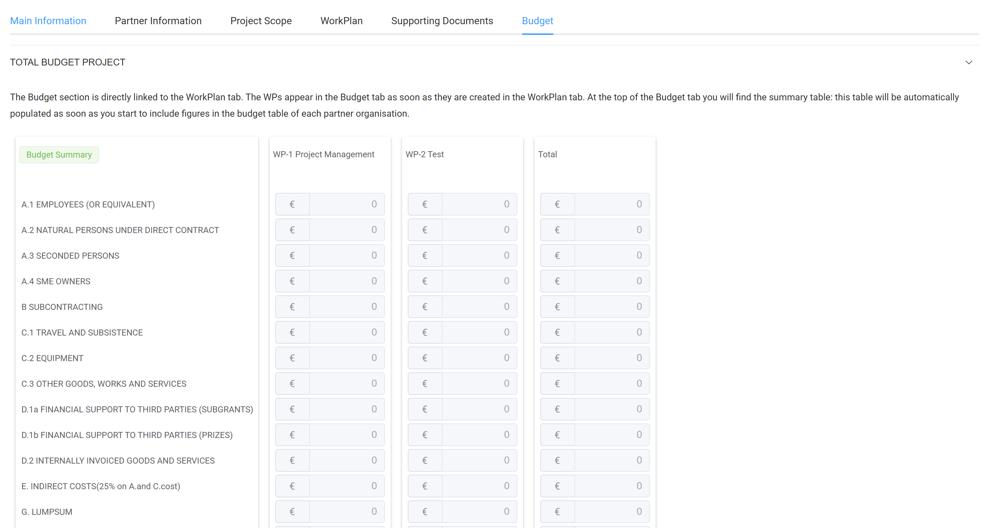
Right under the total budget table, you will find one table per each one of the partners involved into the project. You will be able to fill in all the cells which appear white.
For each partner, you must indicate the G.LUMPSUM amount, the percentage of EIT funding (the part of the costs which will be covered by EIT) and the percentage of co-funding. To support you in calculating the rates required for allocating the budget among the project partners, please use the Excel file provided in the Call webpage. Specific guidance is provided within the file. As mentioned in the Call Manual, all partners must have a budget, even if it only includes co-funding and no direct EIT funding.
All partners must have a budget allocated (participation of partners with a total budget of EUR 0 is not permitted), either from EIT funding and/or from co-funding.
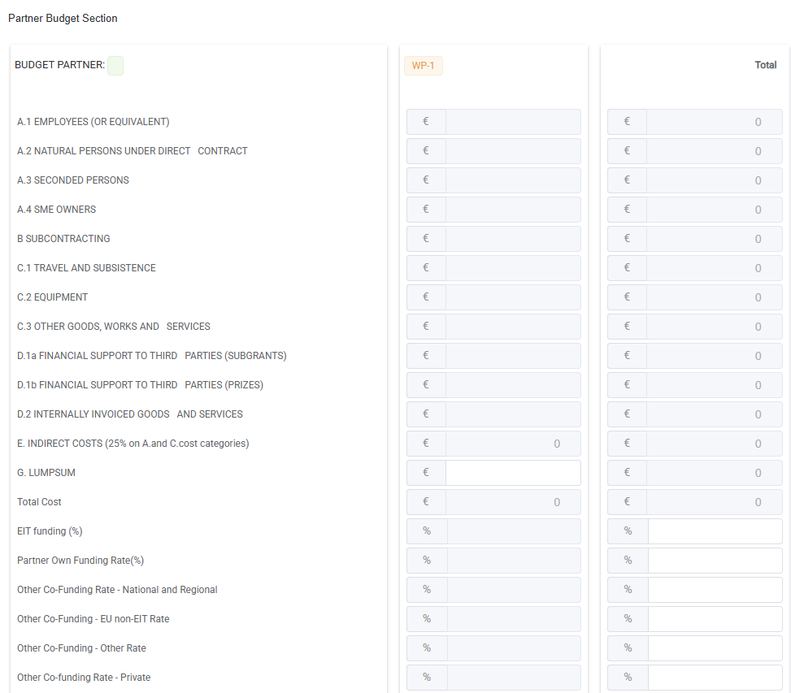
Before moving to the next tab, remember to click on the “save” button.

3. Submit your proposal
We strongly recommend all applicants not to wait until the last day/minute to submit the Application Form.
You should ideally submit it with at least one day of margin: should you encounter any system error while submitting the Application Form, EIT Urban Mobility staff will in fact be able to properly assist you.
When your Application Form is correctly and fully completed, save it one last time and you can then submit it by clicking of the “submit” button:

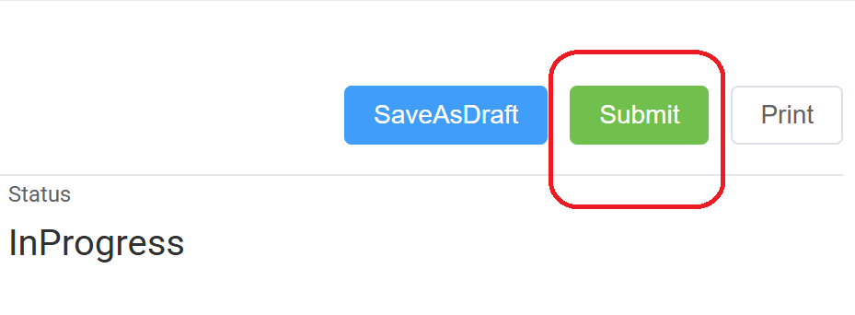

If your Application Form has not been properly completed, i.e.. some mandatory information has not been included, the system will not allow you to submit the Application Form and an error message will inform you about what is missing. You can therefore use the submit button as a “validation” check: in this case, just remember not to click “ok” until you are sure all is finalised.
Once an Application Form is submitted it will not be possible to revert the process any longer, nor to submit a new updated version. Make therefore sure that you submit the Application Form only once you are sure that the information introduced are final.
After clicking “submit” a pop-up message will ask you to confirm or cancel your choice: click OK.
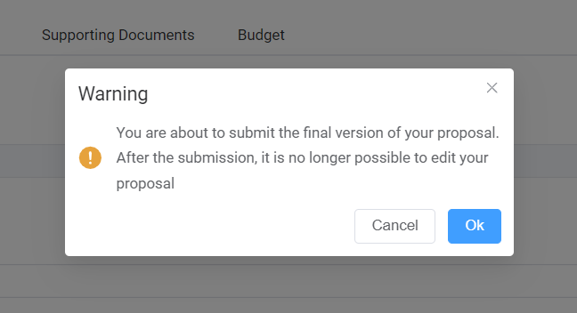

By going into the section “My Applications” you will be able to see the status of your application and therefore see if it was properly submitted or not.
